Chicken Piccata
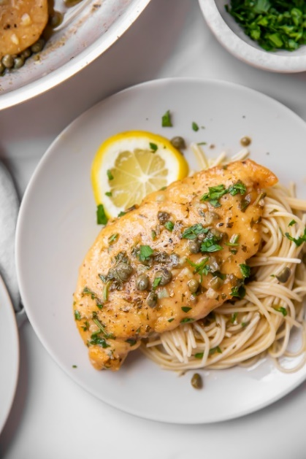
Prep time 10 min Cook time 15 min
4 Servings
Ingredients
4 boneless skinless chicken breast halves
1 tsp cayenne pepper
½ tsp salt
1 tsp ground black pepper
2 tbsp flour
1 tbsp grated parmesan cheese
2 tablespoons olive oil
1 tablespoon capers, drained
2 cloves garlic, minced
½ cup white wine
2 tbsp fresh lemon juice
½ cup chicken broth
3 tablespoons butter
2 tablespoons fresh Italian parsley, chopped
Directions
- Season both sides of chicken breasts with cayenne, salt, and black pepper. Dredge lightly in flour and shake off any excess. Sprinkle parmesan cheese on both sides of chicken breasts.
- Heat olive oil in a skillet over medium-high heat. Place chicken in the pan, reduce heat to medium, and cook until browned and cooked through, about 5 minutes per side. Remove to a plate.
- Cook capers and garlic in reserved oil, smashing about half of the capers lightly to release brine, until warmed though, about 30 seconds.
- Pour white wine into skillet. Scrape any browned bits from the bottom of the pan with a wooden spoon. Cook until reduced by half, about 2 minutes.
- Stir lemon juice, chicken broth, and butter into the reduced wine mixture; cook and stir continuously to form a thick sauce, about 2 minutes. Reduce heat to low and stir parsley through the sauce.
- Return chicken breasts to the pan cook until heated through, 1 to 2 minutes. Serve with sauce spooned over the top. Serve over long pasta if desired.

